**A PRELIMINARY REPORT ON**

“SALOON MANAGEMENT SYSTEM”

SUBMITTED TO THE EDUBRIDGE INDIA PRIVATE LIMITED

**SUBMITTED BY**

**Miss.ABARNA.R Batch No: EON-5755**

## Under The Guidance of

Amruta Deore



# DEPARTMENT OF S PRAYAS CERTIFIED JAVA FULL STACK DEVELOPER 02

**THANE**

**EDUBRIDGE INDIA PRIVATE LIMITED 2021-2022.**

# ACKNOWLEDGMENT

It gives all of us great pleasure in presenting the preliminary project report on **“STYLISH SENORITO”**. With due respect and gratitude we would like to take this opportunity to thank internal guide of our project **Mrs.Amruta Deore** for giving us all the help and guidance we needed. We are really grateful for his kind support. He has always encouraged us and given us the motivation to move ahead. He has put in a lot of time and effort in this project along with us and given us a lot of confidence. Also we wish to thank all the other people who have helped us in the successful completion of this project.

**Miss.Abarna Ramesh**

# ABSTRACT

Saloon Management System which help normal people to know about the saloon and its location .In addition it helps to maintain make appointment for Laser treatment, Skin treatment .Making appointment of multiple people for a big saloon is difficult by using a manual system and may be very time consuming. All these problems are solved using this project. Saloon Management System is a software which is helpful for normal people to make an easy appointment with a beautician who is export

in their respective field. Our Saloon Management System deals with the various

activities related to the saloon and also to know more details about saloon and Staffs.

**Chapter 1**

# INTRODUCTION

* 1. **INTRODUCTION**

Saloon Management System is making appointment of people for a big saloon is difficult by using a manual system and may be very time consuming. Saloon Management System allows user to keep up to date profile . It’ll also facilitate keeping all the records of users, such as their id, name, mailing, address, phone number. So all the information about an user will be available and provide personalized experience.

# SCOPE

Without a Saloon Management System, appointment and tips of beautician and speciality of saloon is difficult for normal people. Saloon Management System have a lots of information about saloon .In addition it have request information and we can give feedback to the saloon .we can also easy to find location of saloon by the help of website link.

# SYSTEM REQUIREMENTS

## Software Requirements

1. Operating System - Windows 10.

2. Platform – Notepad++.

3. Language - HTML, CSS, Javascript.

4. Files – stylesheet ,html.

# UML DIAGRAMS

## Use case Diagram

The following UML use case diagram shows the working of a Saloon Management System.Moreover, it has eight use cases that show the particular functionality of the media provider. The six use cases are; appointment form, beauticean info, choose department of beautician, Make request information ,process of appointment ,manage feedback form.The user, on the other hand, easy find the location of saloon .The interactions of the user and management system are what sum up the saloon management use case diagram example.

**Uml Diagram for Saloon Management System**

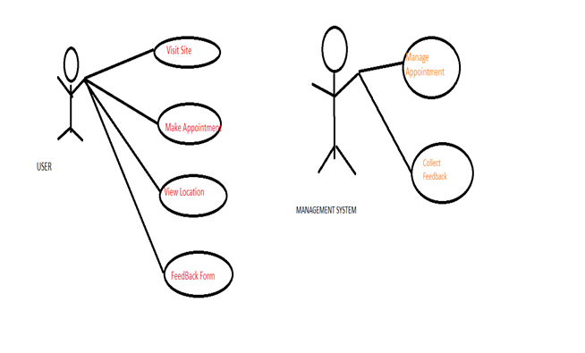

# MODULE

## WELCOME

Welcome module will help to know about the Saloon .Any one can see website of our saloon management.

**HTML file**

<!DOCTYPE html>

<html>

<head>

<title>Welcome page</title>

<link href='style2.css' rel='stylesheet'>

</head>

<body>

<div class="dropdown">

<nav>

<img class="logo" src="onlinelogomaker-082821-1341-0106-500.jpg">

<ul>

<li><a href="#">Home</a></li>

<li><a href="#">Courses <i class="fas fa-caret-down"></i></a>

<ul>

<li><a href="file:///C:/Users/ELCOT/Documents/couresfree.html">Free courses</a></li>

<li><a href="file:///C:/Users/ELCOT/Documents/bridal.html">Bridal intenship</a></li>

</ul>

</li>

<li><a href="#">Offers <i class="fas fa-caret-down"></i></a>

<ul>

<li><a href="file:///C:/Users/ELCOT/Documents/hairstyle.html">HairCut</a></li>

<li><a href="file:///C:/Users/ELCOT/Documents/lasertreatment.html">LaserTreatment</a></li>

</ul>

</li>

<li><a href="#">Speciality <i class="fas fa-caret-down"></i></i></a>

<ul>

<li><a href="file:///C:/Users/ELCOT/Documents/product.html">Quality Product</a></li>

<li><a href="file:///C:/Users/ELCOT/Documents/gallery.html">Gallery</a></li>

</ul>

</li>

<li><a href="file:///C:/Users/ELCOT/Documents/appointment.html">Appointment</a></li>

<li><a href="#">About us <i class="fas fa-caret-down"></i></a>

<ul>

<li><a href="file:///C:/Users/ELCOT/Documents/oursites.html">Our Team</a></li>

<li><a href="file:///C:/Users/ELCOT/Documents/ourteam.html">Reviews</a></li>

</ul>

</li>

<li><a href="file:///C:/Users/ELCOT/Documents/contact.html">Contact</a></li>

<li><a href="file:///C:/Users/ELCOT/Documents/logout.html">Logout</a></li>

<li><a style="text-decoration: underline" href="file:///C:/Users/ELCOT/Documents/loginproject.html">Login</a></li>

</ul>

</nav>

</div>

<div>

<img class="body" src="C:\Users\ELCOT\Documents\html\heaven.jpg">

</div>

<div class="footer">

<h2>Copyright &copy; Stylish Senorito pro. All Rights Reserved.<br><br><u>email-id: stylishsenorito21

@gmail.com</u></h2>

</div>

</body>

</html>

Css File

body{

background: #dedede;

font-family: arial;

margin: 0;

padding: 0;

}

.dropdown{

margin: 0 auto;

}

nav{

height: 65px;

background: #2c3e50;

box-shadow: 0 10px 15px rgba(0,0,0,0.1);

}

.logo{

padding: 5px 0 0 80px;

width: 150px;

height: auto;

}

nav ul{

padding:0;

margin:0;

float:right;

margin-right: 30px;

}

nav ul li{

background: #2c3e50;

position: relative;

list-style: none;

display: inline-block;

}

nav ul li a{

display: block;

padding: 0 15px;

color: white;

text-decoration:none;

line-height: 65px;

font-size: 17px;

}

nav ul li a:hover{

background: #243342;

}

nav ul ul{

position: absolute;

top: 65px;

display: none;

}

nav ul li:hover ul{

display: block;

}

nav ul ul li{

width: 150px;

float: none;

display: list-item;

position: relative;

}

.body{

height: auto;

width: auto;

}

.footer {

padding: 20px;

text-align: center;

background: #2c3e50;

margin-top: 20px;

width:100%;

}

**Screenshots of Welcome page**

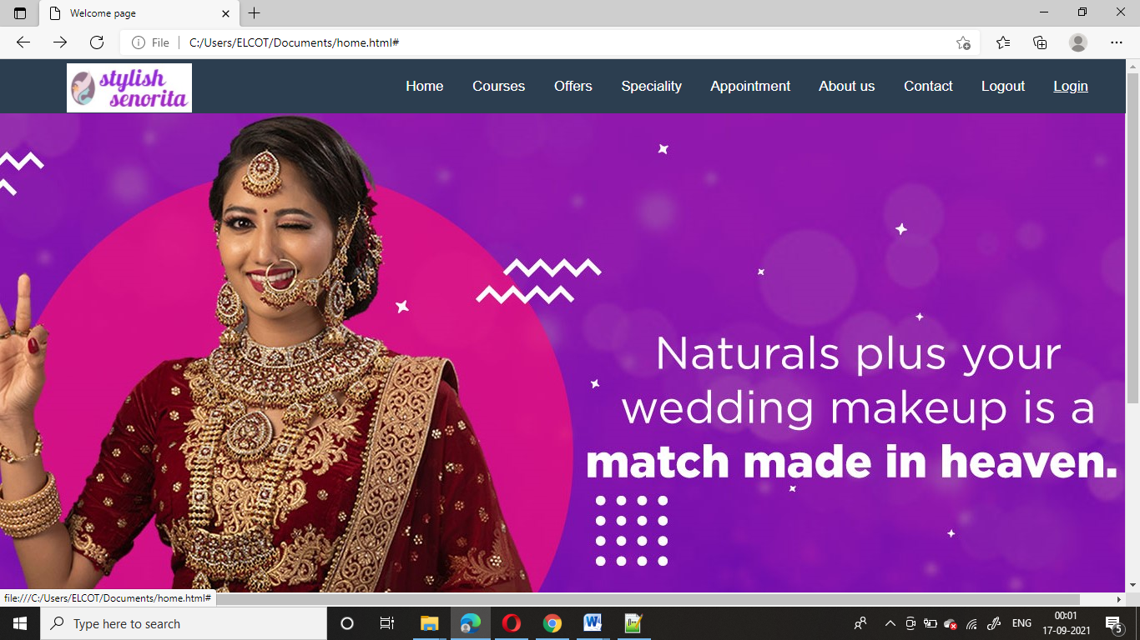

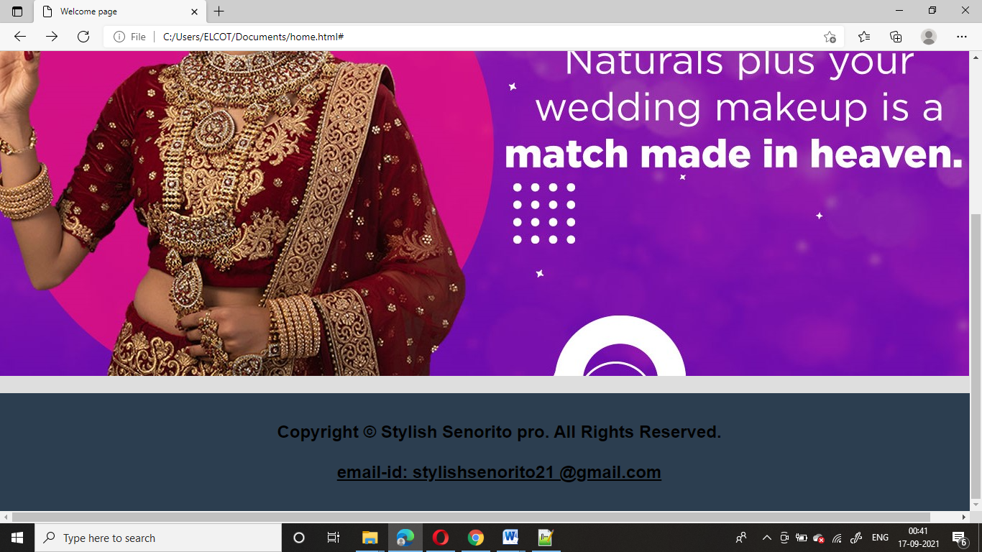

* + 1. **LOGIN FORM MODULE**

## 

Login Form is used to make an appointment easily. Its help to saloon for how many clients we are having.

**Html File**

<!DOCTYPE html>

<html>

<head>

<meta charset="utf-8">

<title>login form</title>

<link rel="stylesheet" href="style.css">

</head>

<body>

<div class="center">

<h1>login</h1>

<form method="post">

<div class="txt_field">

<input type="text" required>

<span></span>

<label>Username</label>

</div>

<div class="txt_field">

<input type="password" required>

<span></span>

<label>Password</label>

</div>

<div class="pass">Forgot Password</label></div>

</form>

<a href="projectnavigation.html"><script>

function msg()

{

alert("Welcome!!!");

}

</script>

<form>

<center><input type="button" onclick="msg()" value="login"><center>

</a>

</form>

<div class="signup_link">

Not a member? <a href="file:///C:/Users/ELCOT/Documents/projectregistration.html">signup</a>

</div>

</form>

<html>

**Css File**

body{

margin: 0;

padding: 0;

background-image: url("fronti.jpg");

background-size: cover;

height: 100vh;

overflow: hidden;

}

.center{

position: absolute;

top: 50%;

left: 50%;

transform: translate(-50%, -50%);

width: 400px;

background: white;

border-radius: 10px;

}

.center h1{

text-align: center;

padding: 0 0 20px 0;

border-bottom: 1px solid silver;

}

.center form{

padding: 0 40px;

box-sizing: border-box;

}

form .txt_field{

position: relative;

border-bottom: 2px solid #adadad;

margin: 30px 0;

}

.txt_field input{

width: 100%;

padding: 0 5px;

height: 40px;

font-size: 16px;

border: none;

background: none;

outline: none;

}

.txt_field label{

position: absolute;

top: 50%;

left: 5px;

color: #adadad;

transform: translateY(-50%);

font-size: 16px;

pointer-events: none;

transition: .5s;

}

.txt_field span::before{

content:'';

position: absolute;

top: 40px;

left: 0;

width: 100%;

height: 2px;

background: #2691d9;

}

.txt_field input:focus ~ label,

.txt_field input:valid ~ label{

top: -5px;

color: #2691d9;

}

.txt_field input:focus ~ span::before,

.txt_field input:valid ~ span::before{

width: 100%

}

.pass{

margin: -5px 0 20px 5px;

color: #a6a6a6;

cursor: pointer;

}

.pass:hover{

text-decoration: underline;

}

input[type="button"]{

width: 100%;

height: 50px;

border: 1px solid;

background: #2691d9;

font-size: 18px;

color: #e9f4fb;

font-weight: 700;

cursor: pointer;

outline: none;

}

input[type="button"]:hover{

border-color: #2691d9;

transition: .5s;

}

.signup_link{

margin: 30px 0;

text-align: center;

font-size: 16px;

color: #666666;

}

.signup_link a{

color: #2691d9;

text-decoration: none;

}

.signup_link a:hover{

text-decoration: underline;

}

**Screenshot for Login Form**

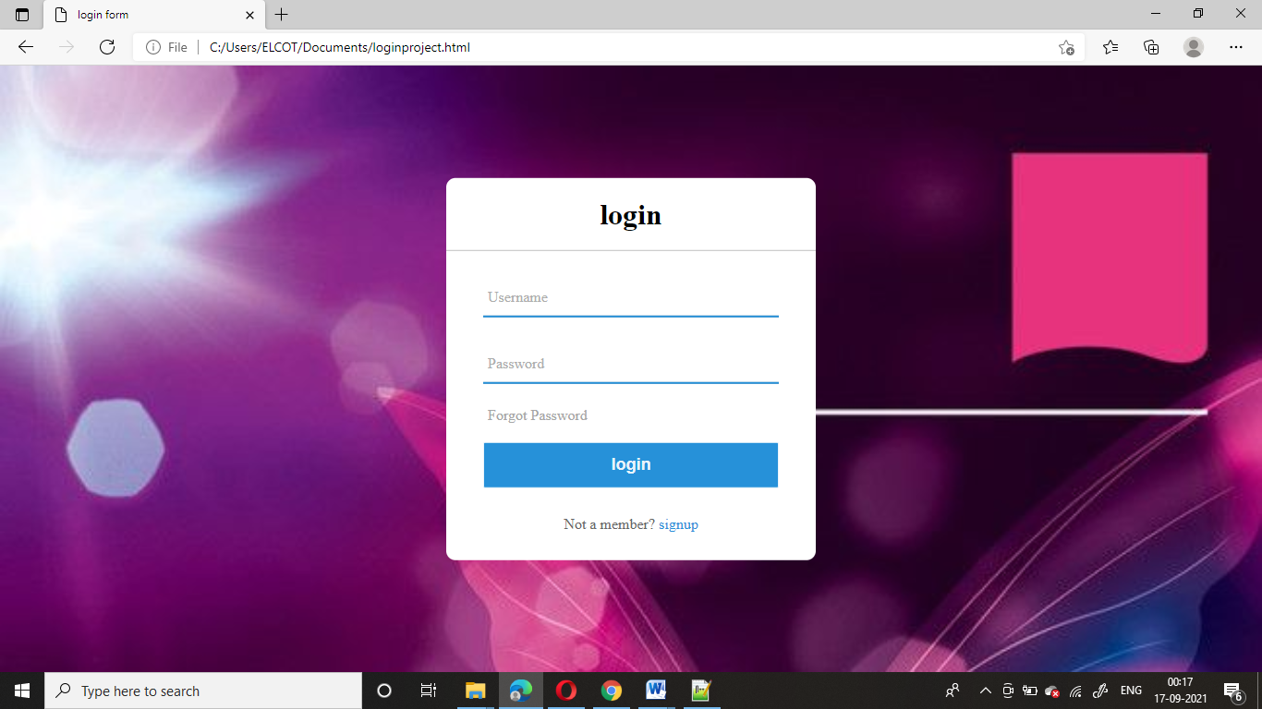

## 1.5.3 REGISTRATION FORM MODULE

## 

Registration Form is used create the member in Saloon.

**Html File**

<html>

<head>

<title>Student Registration Form</title>

</head>

<style>

.project{

background-image:url("fronti.jpg");

background-size: cover;

color:white;

}

tr{

color: white;

}

</style>

<body>

<div class="project">

<u><center><h1>Registration Form</h2></center></u>

<div class="project">

<table align="center" cellpadding ="10">

<tr style="color:white">

<td>FIRST NAME</td>

<td><input type="text" name="username" maxlenght="30"/>

(max 30 characters a-z and A-Z)

</td>

</tr>

<tr>

<td>LAST NAME</td>

<td><input type="text" name="lastname" maxlenght="30"/>

(max 30 characters a-z and A-Z)

</td>

</tr>

<tr>

<td>DATE OF BIRTH</td>

<td>

<input type="date" id="dob">

</td>

</tr>

<tr>

<td>E-mail id</td>

<td>

<input type ="email" id="email" name="email"/>

</td>

</tr>

<tr>

<td>ADDRESS</td>

<td><textarea rows="2" cols="20"></textarea>

</td>

</tr>

<tr>

<td>PASSWORD</td>

<td><input type ="password" id="password" name="password"/>

</td>

</tr>

<tr>

<td>CONFIRM PASSWORD</td>

<td><input type ="password" id="Confirm password" name="Confirm password"/>

</td>

</tr>

<tr>

<td>GENDER</td>

<td><input type ="radio" id="gender" name="gender" value="male"/>male

<input type ="radio" id="gender" name="gender" value="female"/>female

</td>

</tr>

<tr>

<td>MOBILE NUMBER</td>

<td><input type="tel" name="telephone"pattern="[0-9]{2}-[0-9]{2}-[0-9]{6}" required>

</td>

</tr>

<tr>

<td>

<tr>

<td>NATIONALITY</td>

<td><input type="text" name="nation">

</td>

</tr>

<tr>

<td>COUNTRY NAME</td>

<td><select name="country name" id="country name">

<option value="india"> india </option>

<option value="japan"> japan </option>

<option value="china"> china </option>

<option value="russia"> russia </option>

<option value="canada"> canada </option>

<option value="lucknow"> lucknow </option>

<option value="nepal"> nepal </option>

</td>

</tr>

<tr>

<td>INTEREST</td>

<td>

<input type ="checkbox" id="interest" name="hair cut" value="hair cut"/>hair cut

<input type ="checkbox" id="interest" name="pedicure" value="pedicure"/>pedicure

<input type ="checkbox" id="interest" name="make up" value="makeup"/>make up

<input type ="checkbox" id="interest" name="others" value="others"/>others

</td>

</tr>

<tr>

<td>problem</td>

<td>

<input type ="checkbox" id="problem" name="hair fall" value="hair fall"/>hair fall

<input type ="checkbox" id="problem" name="skin" value="skin"/>skin

<input type ="checkbox" id="problem" name="tan" value="tan"/>tan

<input type ="checkbox" id="problem" name="no problem" value="no problem"/>no problem

</td>

</tr>

<tr>

<td colspan="2" align="center">

<input type="reset" value="Reset">

<a href="file:///C:/Users/ELCOT/Documents/loginproject.html"><input type="submit" value="register"></a>

</td>

</tr></table>

</div>

</body>

</html>

**Screenshot of Registration Form**

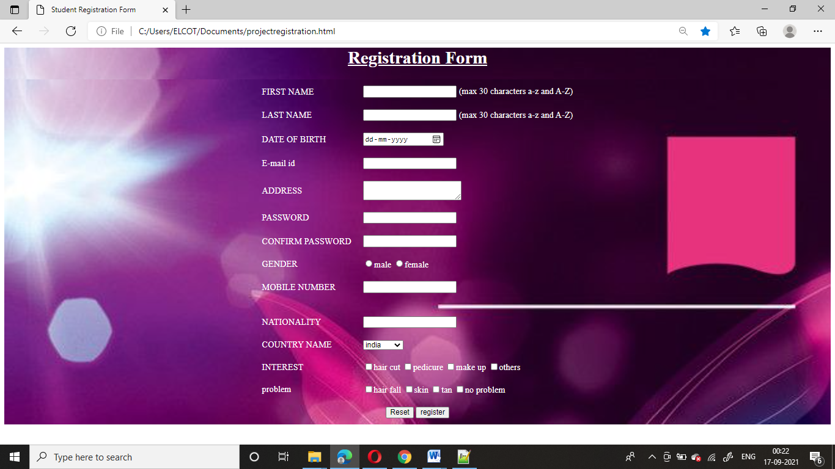

## APPOINTMENT FORM

This module will help the people to make an easy appointment from anywhere if internet is present.

**HTML file**

<html>

<head>

</head>

<style>

body{

background-color:#9e589f;

}

input[type=text], select {

width: 100%;

padding: 12px 20px;

margin: 8px 0;

display: inline-block;

border: 1px solid #ccc;

border-radius: 4px;

box-sizing: border-box;

}

input[type=email]

{

width: 100%;

padding: 12px 20px;

margin: 8px 0;

display: inline-block;

border: 1px solid #ccc;

border-radius: 4px;

box-sizing: border-box;

}

input[type=date]

{

width: 100%;

padding: 12px 20px;

margin: 8px 0;

display: inline-block;

border: 1px solid #ccc;

border-radius: 4px;

box-sizing: border-box;

}

input[type=submit] {

width: 100%;

background-color: pink;

color: white;

padding: 14px 20px;

margin: 8px 0;

border: none;

border-radius: 4px;

cursor: pointer;

font-size:20px;

}

input[type=submit]:hover {

background-color: #FB8DA0;

}

</style>

<body>

<div>

<h1 style="border-radius:50%"><center>REQUEST AN APPOINTMENT<center></h1></div>

<div class="d"><h3>Find an Appointment</h3></div>

<h5>Please note: This is a request only. The Beauty Parlour will contact you to confirm your appointment.</h5>

</div>

<form>

<label for="Appointment">Select Appointment Type</label>

<select name="Appointment Type" id="Appointment">

<option value="Bang Trim">Bang Trim</option>

<option value="Haircut+style1">Haircut+style1</option>

<option value="Haircut+style2">Haircut+style2</option>

<option value="Haircut+style3">Haircut+style3</option>

<option value="New client Cut">New client Cut</option>

<option value="Blowout">Blowout</option>

<option value="Contioning Treatment">Contioning Treatment</option>

<option value="Root Retouch">Root Retouch</option>

<option value="Full Body Laser Treatment">Full Body Laser Treatment</option></select>

<label for="Stylist">All Stylist</label>

<select name="Stylist" id="Stylist">

<option value="Dean">Dean</option>

<option value="Desiree">Desiree</option>

<option value="Gabby">Gabby</option>

<option value="Jamine">Jamine</option>

<option value="keterya">Keterya</option>

<option value="Nina">Nina</option>

<option value="Shannon">Shannon</option></select>

<label for="email-id">Email-id</label>

<input type ="email" id="email-id" name="Email-id" placeholder="Your Registered Email-id..">

<label for="date">Appointment Date</label>

<input type="date" id="dob">

<a href="projectnavigation.html"><script>

function msg()

{

alert("your appointment date will be book today.later,confirmation mail will came soon at your registration Email.id");

}

</script>

<input type="submit" onclick="msg()" value="Search">

</a>

</body>

</html>

**Screenshot of Appointment Form**

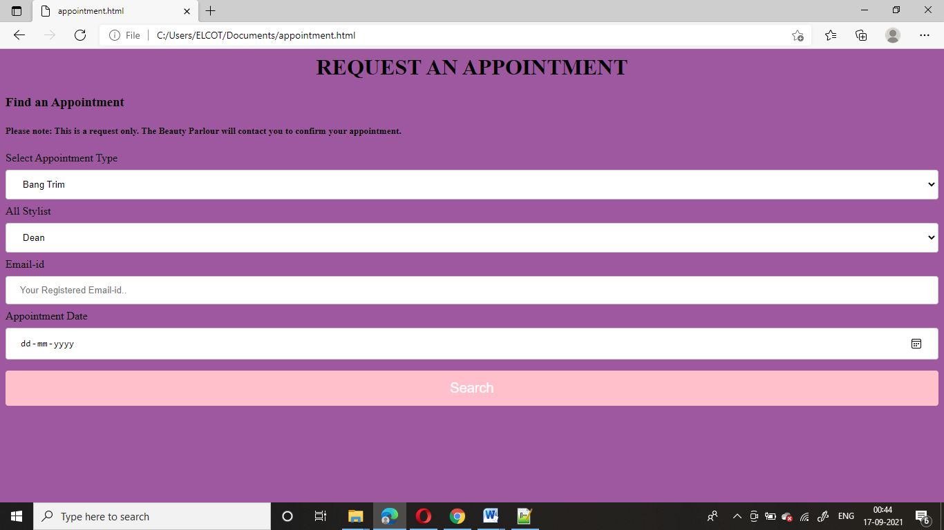

## CONTACT US

This module will help to know about the Saloon location easily, help to rural people or long distance easily contact by phone number

**Html File**

<html>

<head>

</head>

<style>

body{

background-color:#9e589f;

}

h1 {

background-color:#D5DBDB;

}

</style>

<body>

<h1><center>Contact Us</center></h1>

<center><img src="C:\Users\ELCOT\Documents\html\contas.png"></center>

<h3 style="color:white">Contact Us For any Query call Us–

General Help Line Number — 9641628781 (Monday-Saturday 10:00pm-6:00pm)

Beautician Course Helpline Number– 7980052194 ( Monday to Saturday 10:00am – 6:00 Pm)</h3>Contact Us For any Query call Us–

General Help Line Number — 9641628781 (Monday-Saturday 10:00pm-6:00pm)

Beautician Course Helpline Number– 7980052194 ( Monday to Saturday 10:00am – 6:00 Pm)

<h4 style="white">Fashion Designer and Tailoring Help line Number— 8420368329 ( Monday to Saturday 10am – 6 Pm)

Nursing Training and Computer Courses Help line Number — 9875544641 (Monday to Saturday 10am – 6 Pm)</h4>

<h1>All Number Whatsap Available Any Time</h1>

<h5 style="color:white">Contact Us , Head office ..</h5>

<h6>Kolkata</h6>

<ul>

<li>Naihati,</li>

<li>po- Hazinagar , Pin -743135,</li>

<li>District – 24 parganas North,</li>

<li>State – West Bengal .</li>

</ul>

<h2><b>Regional Office</b>Contact Us</h2>

<h6>MUmbai</h6>

<ul>

<li>Karma stambh industrial estate 2nd floor,</li>

<li>LBS Rd, opposite Everest Masala,</li>

<li>LBS Rd, opposite Everest Masala,</li>

</ul><center><img src="C:\Users\ELCOT\Documents\html\paint1.png"></center>

</body>

</html>

**Screenshot of contact us**

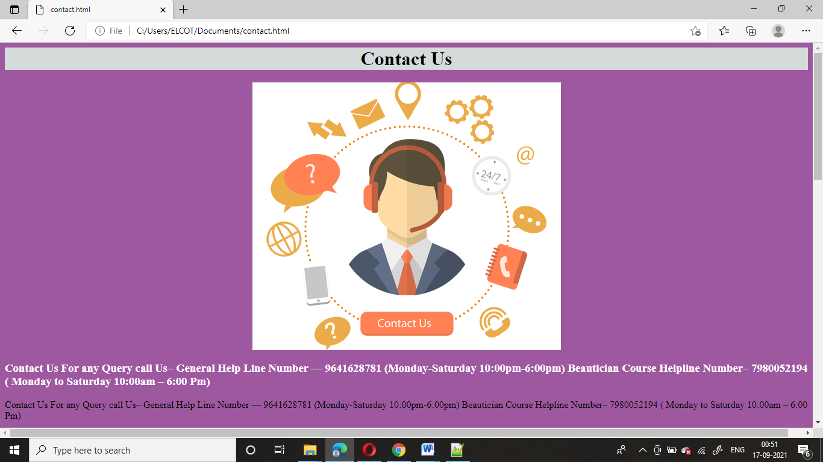

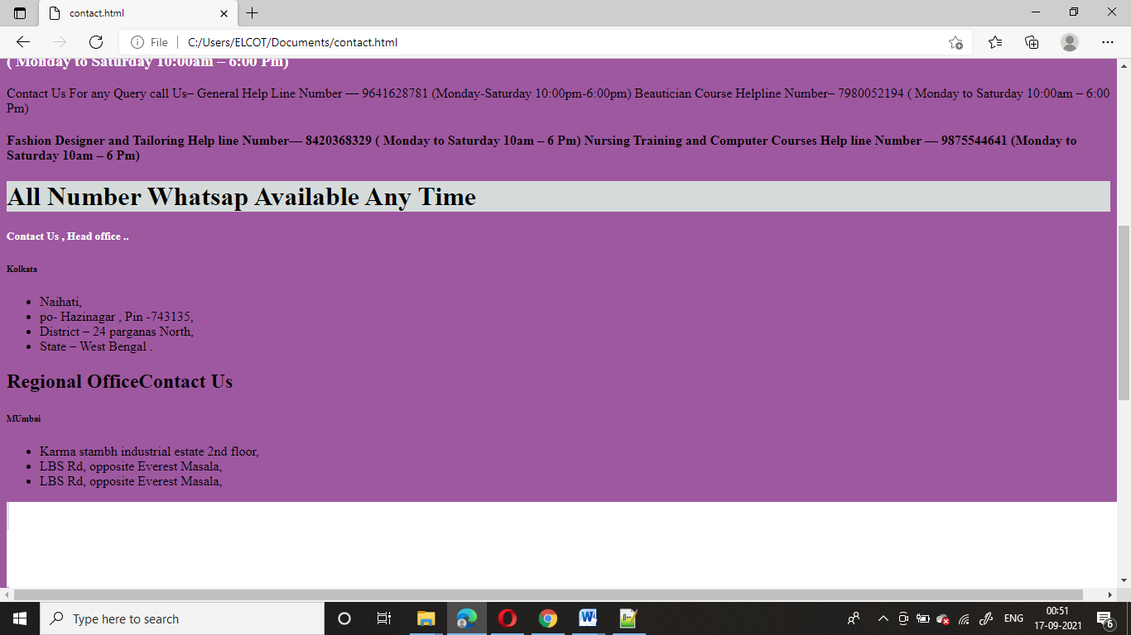

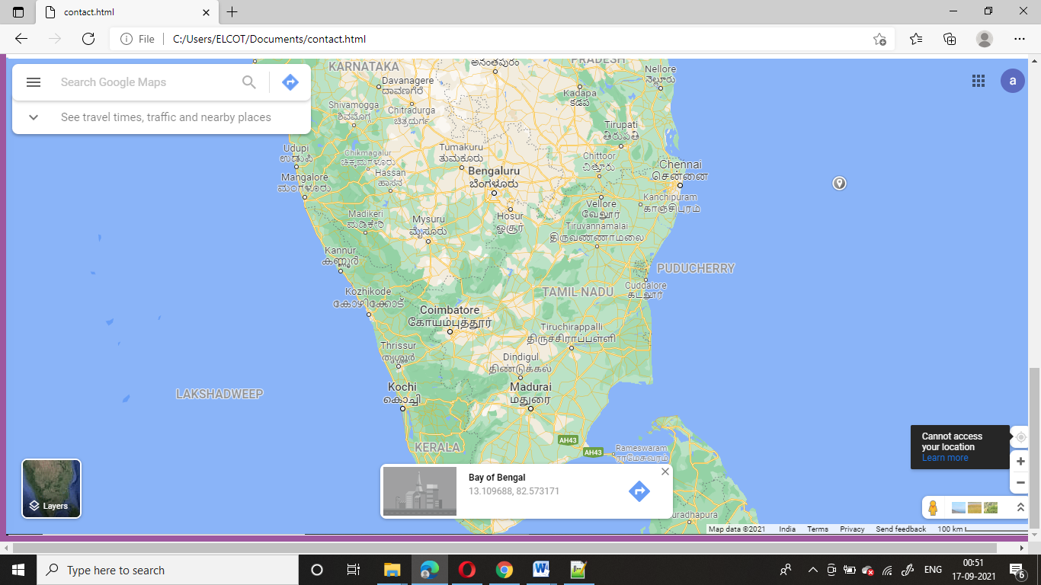

# 1.6 ADVANTAGES

1. Easy appointment making.
2. Check beautician profile.
3. Easy location .
4. User-friendly.
5. Help to rural people what are the courses available in saloon.
6. Also help to long distance relationship.

**Chapter 2**

# CONCLUSIONS

**2.1 CONCLUSION**

Saloon MANAGEMENT SYSTEM can be used by any people to search and appoint a beautician easily. Making appointment of multiple people for a big saloon is difficult by using a manual system and may be very time consuming .All these problems are solved by this project.